INTRODUCTION TO JAVA

Java is a high-level, object-oriented programming language developed by Sun Microsystems in 1995. It is mostly used for building desktop applications, web applications, Android apps and enterprise systems.
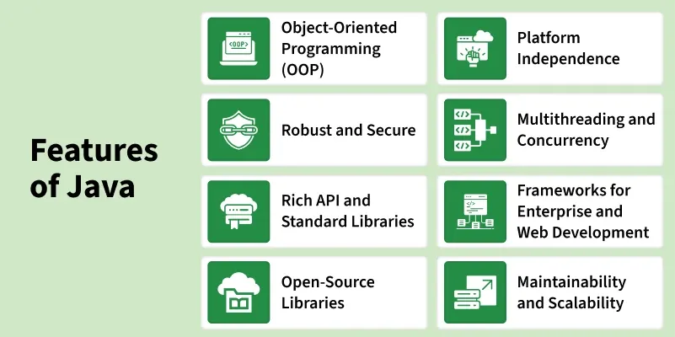
- Object-Oriented Programming (OOP): Java supports OOP concepts to create modular and reusable code.
- Platform Independence: Java programs can run on any operating system with a JVM.
- Robust and Secure: Java ensures reliability and security through strong memory management and exception handling.
- Multithreading and Concurrency: Java allows concurrent execution of multiple tasks for efficiency.
- Rich API and Standard Libraries: Java provides extensive built-in libraries for various programming needs.
- Frameworks for Enterprise and Web Development: Java supports frameworks that simplify enterprise and web application development.
- Open-Source Libraries: Java has a wide range of libraries to extend functionality and speed up development.
- Maintainability and Scalability: Java’s structured design allows easy maintenance and growth of applications.

- Understanding the Hello World Program in Java:
When we learn any programming language, the first step is writing a simple program to display "Hello World". So, here is a simple Java program that displays "Hello World" on the screen.
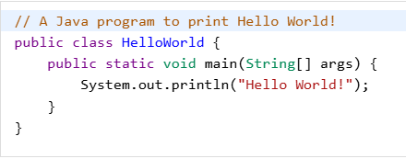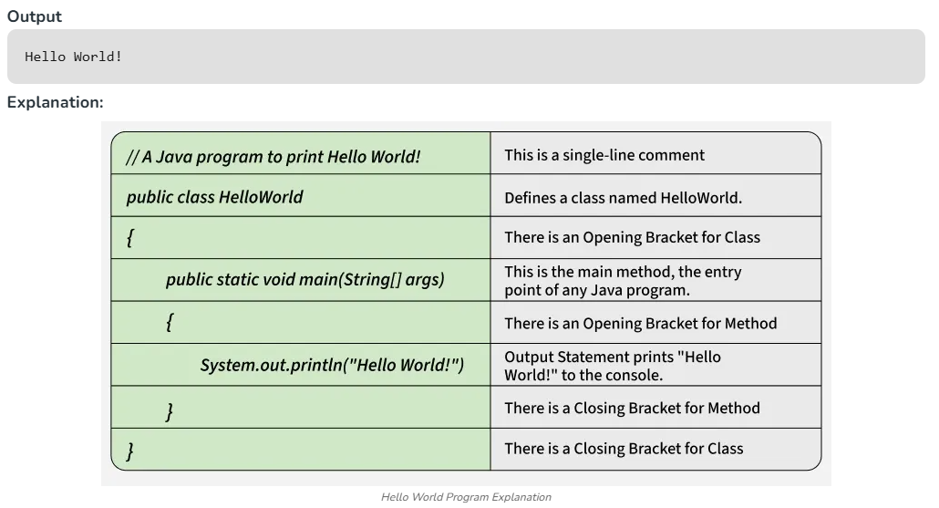
- How to run the above code?
- Write code in a file like HelloWorld.java.
- Java Compiler "javac" compiles it into bytecode "HelloWorld.class".
- JVM (Java Virtual Machine) reads the .class file and interprets the bytecode.
- JVM converts bytecode to machine readable code i.e. "binary" (001001010) and then execute the program.

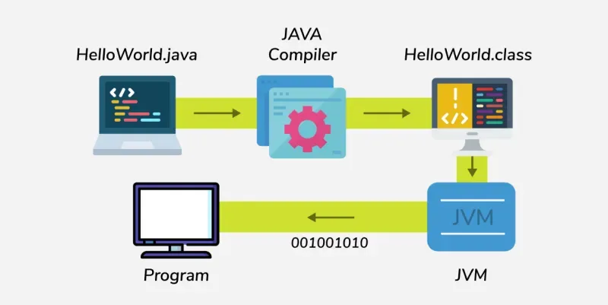
Figure 1: Program Execution Flow
JDK in Java:
Java Development Kit (JDK) is a cross-platform software development kit that provides tools and libraries needed to build Java-based applications and applets. It works together with the JVM (Java Virtual Machine) and JRE (Java Runtime Environment) as part of the core Java setup.
- The JDK includes everything required for Java development — compilers, debuggers, and other essential tools.
- Beginners often get confused between JRE and JDK.
- If you only want to run Java programs, installing JRE is enough.
- But if you want to develop Java applications, you’ll need the JDK, which includes the JRE and additional development tools.

